**LOCATION : NATIONWIDE**

**DATE : 31.03.2017**

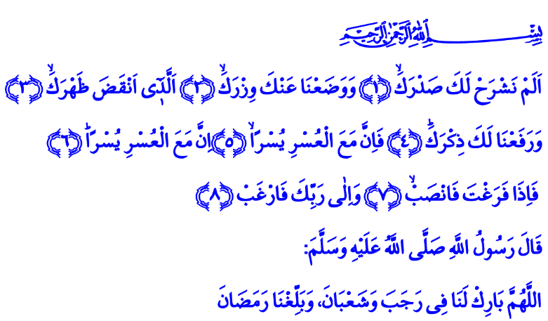

**TURN TO YOUR LORD ALONE WITH HOPE!**

**A Blessed Friday to You, Brothers and Sisters!**

Infinite praise be to the Almighty. He has let us get to the three holy months, the season of grace. We all felt the jubilation of Raghaib night, the harbinger of Ramadan, in our hearts last night. Today, on one hand we are experiencing the abundance of Rajab and the joy of Friday, our weekly feast, on the other. When the season was upon him, Allah’s Messenger (pbuh) used to pray, **“O Allah, Bless for us the months of Rajab and Sha’ban! Get us to Ramadan with faith and in health and well-being!”[1]** May the Almighty Lord bless Rajab and Sha’ban for our nation and for the world of Islam. May He grant all of us to make it to Ramadan having been protected from all evil.

**Honorable Brothers and Sisters!**

There is a great surah called “Al-Inshirah” in our Great Book the Holy Quran. Inshirah is the opening of the heart, the expanding of the chest. It is the exhilaration and becoming quiet of the heart. It was revealed during a time when Allah’s Messenger and his companions were suffering great hardship. The surah gave the news that the hearts of all believers, in the person of Allah’s Messenger (pbuh), would be exhilarated until the Day of Judgement and find peace. It showed us how to unload the burden on our backs, how to elevate our honor, and how to make difficulties easy to deal with.

The Almighty enjoins in Surat al-Inshirah: **“Have We not uplifted your heart for you, O Muhammad, and We removed from you your burden, which weighed so heavily on your back, and elevated your reputation for you? So surely along the hardship there is ease. Surely with that hardship comes more ease.** **So once you have fulfilled your duty, strive in devotion! And turn to your Lord alone with hope!”[2]**

**Brothers and Sisters!**

We understand from the last two verses that there are two conditions for our hearts to be uplifted, our burden to be removed, our reputation to be elevated, and our hardship to be eased. The first one is abiding by the Lord’s command to **فَاِذَا فَرَغْتَ فَانْصَبْۙ “work, strive, endeavor, produce!”** In other words, not wasting this short life. Not leading a vain life which is most precious for us. Striving for goodness, for truth, for helpful things. Making an effort to make the earth a more livable place.

**Honorable Believers!**

The second condition for being honored with the things revealed in the surat al-Inshirah is turning to Allah as per the verse **وَاِلٰى رَبِّكَ فَارْغَبْ “Turn to your Lord alone with hope!”** This must be the most important point we must emphasize on Raghaib night. It means working for Allah. Laboring for Allah. Endeavoring for Allah. Sending our wishes and desires to Allah. Striving for our Lord’s favor instead of fame, rank or wealth.

**Dear Brothers and Sisters!**

We are also going through difficult periods today as Muslims. We are at a period when every believer’s heart feels tight. We are at a time when we need exhilaration the most. We are in need of finding peace and getting read of the burden on our back. Then come, brothers and sisters! Let us strive in determination to that end. Let us live for the Lord’s favor, not for desire and fancy. Let us make an effort to work and endeavor more for truth, for the right path, for justice, for goodness, and for the humankind.

Only then will the Almighty Lord exhilarate our hearts. He will relieve the burden from our chests. He will clear our sins. He will make our struggles easier to deal with. Only then will the Almighty deliver us from all evil that takes away our freedom. He will turn our labor into mercy. He will elevate our reputation. He will make us a glorious ummah again.

**Brothers and Sisters!**

When the Almighty Lord sent Moses (as) to the Pharaoh to invite him to the true path, Prophet Moses prayed,**رَبِّ اشْرَحْ ل۪ي صَدْر۪يۙ** **وَيَسِّرْ ل۪ٓي اَمْر۪ي**  **“My Lord! Expand for me my breast with assurance! And ease for me my task.”[3]** Today, we supplicate like Moses (as) to our Lord and say:

O Lord! Uplift our hearts! Ease our hardship. Grant us to be among those who spend every breath in Your cause!

O Allah! Do not let us yield to our desires even for a moment! Make our desire, wish, demand, and passion to be only seeking Your favor!

O Lord! Elevate our honor! Make the Ummah of Islam a glorious one once again!

1. Ahmad b. Hanbal; Müsned, 1/259.
2. Al-Inshirah, 94/1-8.
3. Taha, 20/25-26.

   ***Written by: General Directorate of Religious Services***